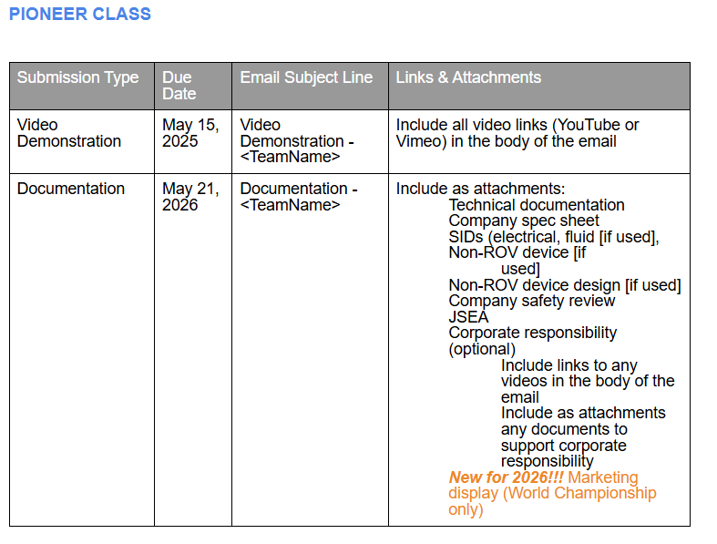
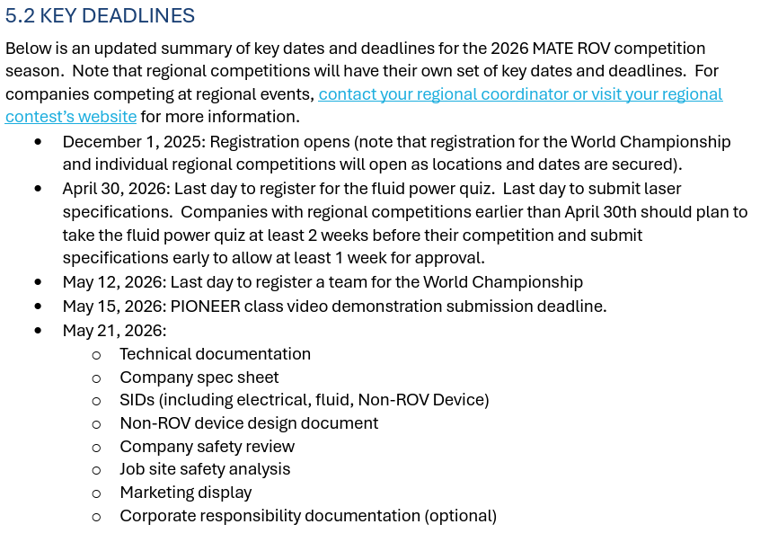

SIDENOTE: For this demonstration, companies only need to collect one basket star and one coral species. The coral species can be recovered by either the substrate or by the coral (e.g., colored chenille pipe cleaners). All product demonstration tasks required for the demonstration video should follow the rules noted in the Product Demonstration notes.

Task A
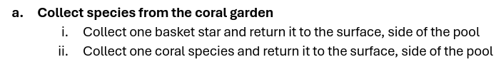

basket stars, simulated by O-balls with a ½-inch PVC base will be located near the coral garden.
coral species will also be located on the coral garden. Coral species will be constructed of colored chenille pipe cleaners attached to a 2-inch end cap with 2-inch knockout cap, and a ½-inch PVC base. The end cap and pipe will be the “substrate” of the coral.

Collecting the coral species by the substrate is defined as removing it and placing it on the pool deck only touching the 2-inch end cap or PVC pipe and not the chenille pipe cleaners.

Coral garden does not need to be built ->
Technical manager Matt Gardner told us so!

Task B
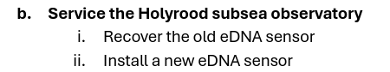
The eDNA sensor will be constructed from ½-inch and 2-inch PVC pipe. A 50 cm length of rope will act as a carrying mechanism. At the start of the product demonstration run, the old eDNA sensor will be on the bottom inside the designated area. The designated area will be a 50 cm square constructed from ½-inch PVC pipe painted yellow.
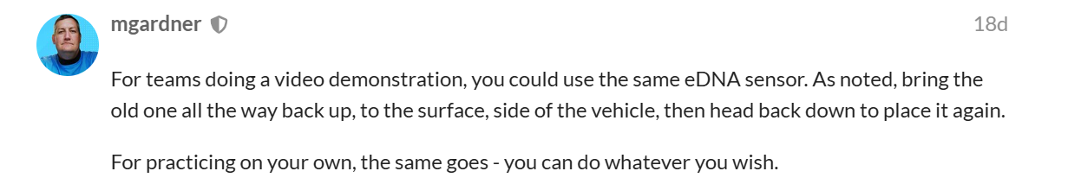
Old eDNA sensor can be the same as the new one. ^^

Task C
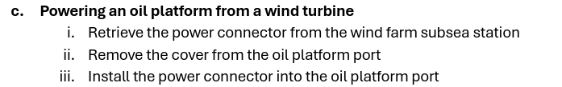
Neither the oil platform nor the wind farm will have surface components; no ropes or lines will connect these subsurface assets to the surface.

The oil platform power connector port will be constructed from 1 ½-inch PVC pipe and a ½-inch PVC framework. The wind farm power connector will be constructed from ½-inch PVC pipe with a screw hook as a carrying mechanism for the power connector. The platform will be constructed from ½ inch PVC pipe and corrugated plastic sheeting. Four meters of wire cable will connect the platform to the power connector.

